

EOG based Calculator
Dep : Scientific Computing
Team ID : SC_09

Team members:-
Number | Name | ID
1 | عمر إبراهيم عبدالله ابراهيم | 2022170264
2 | إبراهيم محمد إبراهيم أحمد | 2022170006
3 | روان محمد حمدي سعد | 2022170159
4 | رؤى حسين محمد عبد الرحيم | 2022170604

Under Guidance :-
Assistant Professor. Manal Tantawi
T.A. Radwa El Husseini

Contents
Chapter 1: Introduction 1
1-Introduction:- 1
Chapter 2 : Data Preparation 3
2.Data Preparation:- 4
2.1 Bandpass filter:- 4
Chapter 3 : Feature Extraction 7
3.Feature Extraction:- 8
3.1 Raw Samples:- 8
3.2 Autoregression (AR) Coefficients:- 9
3.3 Discrete Wavelet Transform (DWT):- 10
3.4 Power Spectral Density (PSD) Features:- 11
3.5 Morphological and Statistical (Mix) Features:- 12
Chapter 4 : Machine Learning and Classification 14
4.Machine Learning and Classification:- 15
4.1 Data Preparation & Processing Pipeline 15
4.2 SVM Configuration (One-vs-One) 15
4.3 Evaluation & Feature Selection 15
Chapter 5 : Results and Conclusion 17
1.Results:- 17
2.Conclusion:- 18

Chapter 1: Introduction

1-Introduction:-
The field of Human-Computer Interaction (HCI) has evolved significantly, aiming to bridge the gap between biological signals and digital systems. One of the most promising technologies in this domain is Electrooculography (EOG), which measures the Cornea-retinal standing potential that exists between the front and the back of the human eye. By capturing these signals, we can translate eye movements and blinks into actionable commands, providing a vital communication channel for individuals with motor impairments or for hands-free system control.
This project focuses on the development of an EOG-based human-computer interface designed to operate a simplified digital calculator. The system architecture follows rigorous digital signal processing and machine learning pipelines. The process begins with specialized preprocessing techniques to filter and normalize the raw EOG data, ensuring that noise and artifacts are minimized before analysis.
A critical component of this research is the comparative study of feature extraction methods. The project evaluates and compares three distinct approaches: Discrete Wavelet Transform (DWT), Autoregression (AR) coefficients, and raw sample analysis. This comparison is essential to determine which feature set most effectively represents the underlying patterns of eye movement for classification.
To interpret these features, a Support Vector Machine (SVM) classifier is utilized. The implementation involves comprehensive hyperparameter tuning to optimize the classification accuracy for each specific command class (digits, operations, and control commands). The final stage of the system is a custom-designed User Interface (UI). This interface is optimized for efficiency, ensuring that any digit from 0 to 9 or arithmetic operation (+, -, x, /) can be selected within a maximum of two eye movements, followed by a blink for selection. The result is an integrated, real-time system that demonstrates the practical application of bio-signal processing in assistive technology.

Chapter 2 : Data Preparation

2.Data Preparation:-
To ensure the integrity of the EOG data before feature extraction and classification, the raw signals undergo a rigorous preprocessing pipeline consisting of one main stage:
- Bandpass filter

2.1 Bandpass filter:-
Unprocessed EOG data is frequently contaminated with various environmental and physiological noises, including 50/60 Hz powerline interference and Electromyography (EMG) artifacts from surrounding facial muscles. A bandpass filter is utilized to isolate the specific frequency spectrum where the meaningful EOG information resides (typically between 0.5 Hz and 20 Hz for capturing saccades and blinks). This process effectively attenuates unwanted high-frequency noise and residual low-frequency artifacts, significantly enhancing the Signal-to-Noise Ratio (SNR).

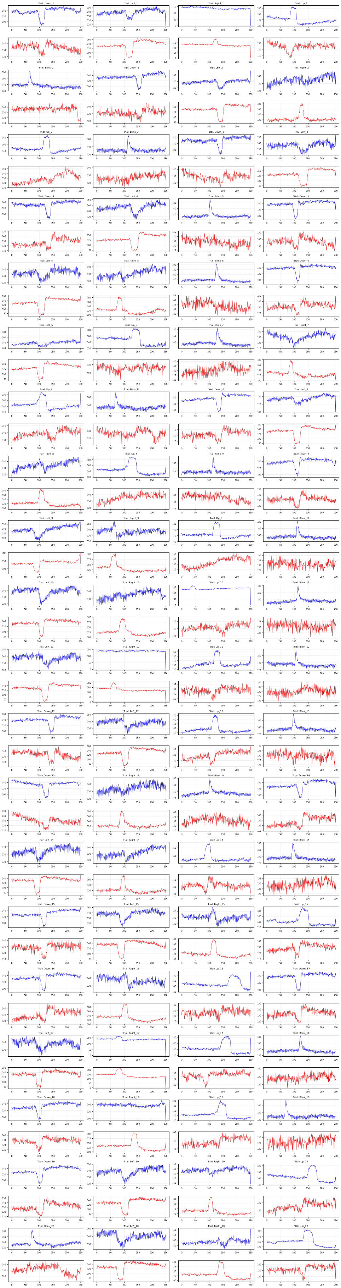
Figure 2.1 Original Signals
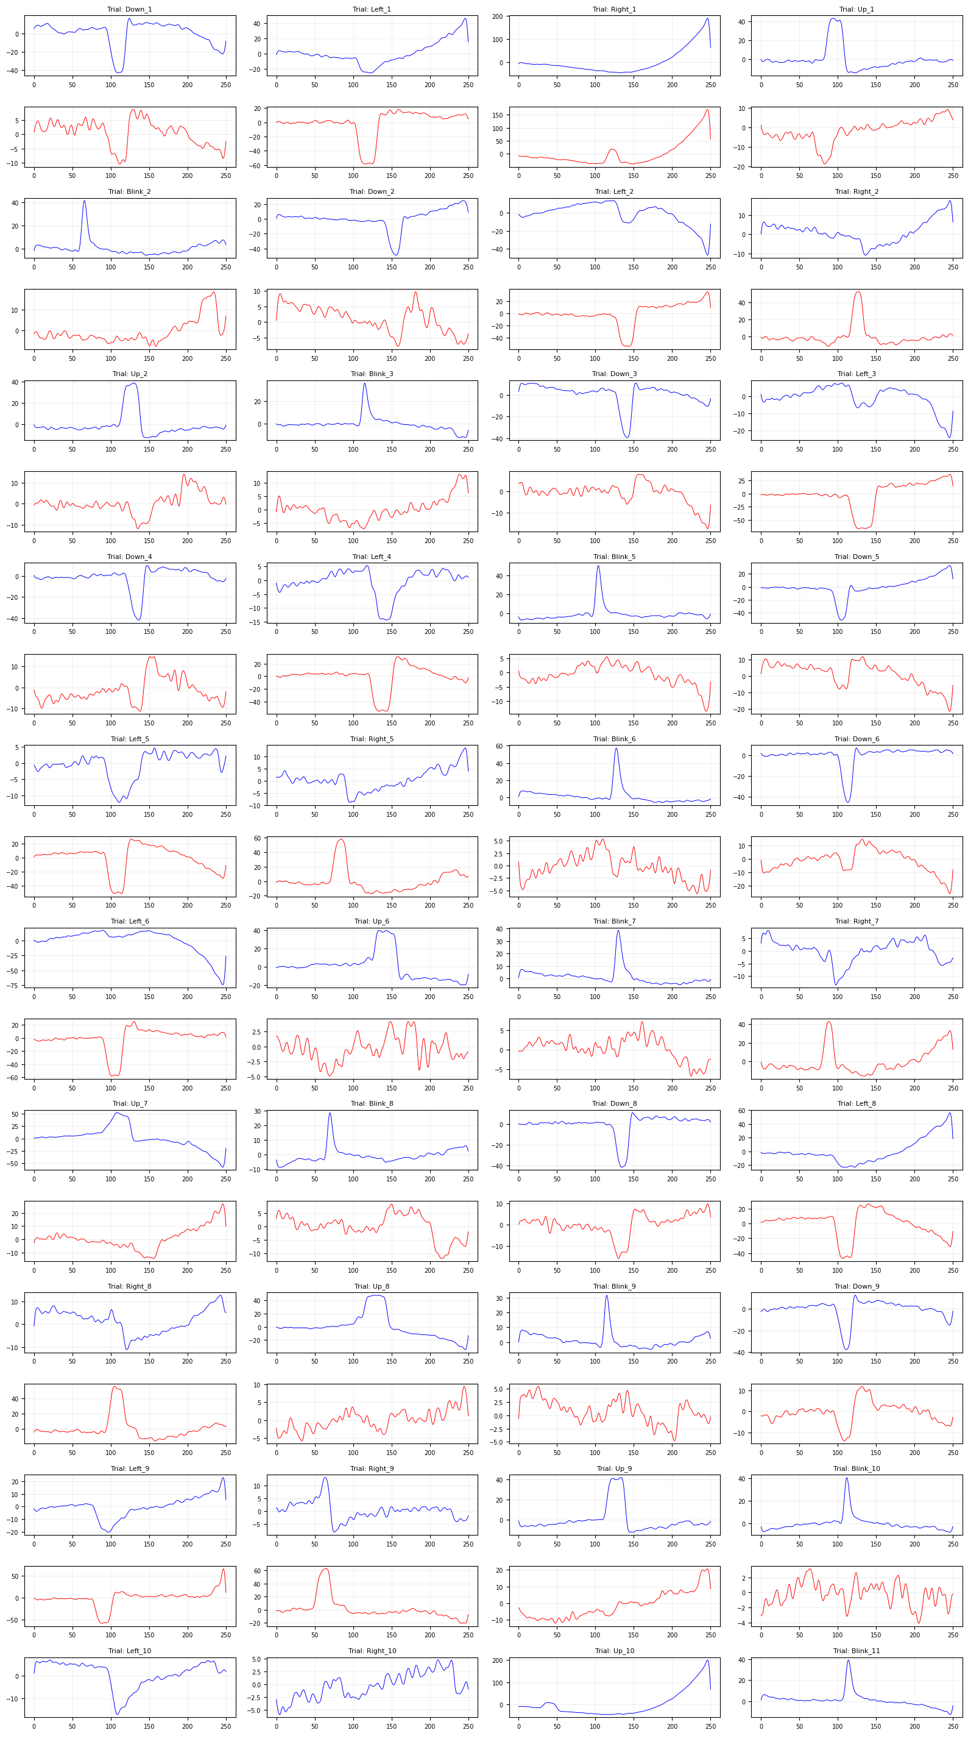
Figure 2.1 Signal after filtered

Chapter 3 : Feature Extraction

3.Feature Extraction:-
Following the preprocessing stage, extracting robust and discriminative features from the EOG signals is critical for the performance of the Support Vector Machine (SVM) classifier. The choice of feature extraction heavily dictates the classifier's computational efficiency and accuracy. In this study, three distinct approaches are evaluated and compared: Raw Samples, Autoregression (AR) Coefficients, and Discrete Wavelet Transform (DWT).

3.1 Raw Samples:-
This approach involves flattening the preprocessed EOG signal windows and using the individual amplitude values directly as the feature vector for the SVM.
- Advantages:
- Zero Extraction Overhead: It requires no additional mathematical transformations or computational resources prior to classification.
- Complete Information Preservation: Absolutely no data is discarded, ensuring that the exact morphology of the time-domain signal is passed to the classifier.
- Disadvantages:
  - High Dimensionality: Feeding raw samples directly leads to massive feature vectors, making the SVM susceptible to the "curse of dimensionality" and significantly increasing training time.
  - Shift Variance: It is highly sensitive to slight temporal shifts. If a user blinks slightly earlier or later within the recording window, the raw sample values at specific indices will change drastically, potentially confusing the SVM.
  - Redundancy: Neighboring samples in EOG are highly correlated, meaning much of the data fed to the classifier is redundant noise rather than distinct discriminatory features.

3.2 Autoregression (AR) Coefficients:-
The Autoregressive model assumes that the current value of the EOG signal can be predicted as a linear combination of its previous values. The extracted features are the estimated coefficients (weights) of this model.
- Advantages:
Dimensionality Reduction: AR models compress the entire signal window into a very small, fixed number of coefficients (e.g., an order-6 AR model yields only 6 features), making SVM training exceptionally fast.
Spectral Representation: AR coefficients effectively capture the frequency spectrum and power distribution of the signal in a highly condensed format.
- Disadvantages:
Stationarity Assumption: AR modeling mathematically assumes the signal is stationary (its statistical properties do not change over time). However, EOG signals containing rapid saccades and blinks are inherently non-stationary, meaning the AR model might fail to capture abrupt, transient changes accurately.

3.3 Discrete Wavelet Transform (DWT):-
DWT decomposes the EOG signal into multiple levels of "Approximation" (low-frequency) and "Detail" (high-frequency) coefficients. By selecting specific decomposition levels, we can isolate the exact frequency bands corresponding to eye movements.
- Advantages:
            - Non-Stationary Signal Handling: Unlike AR, wavelets provide excellent time-frequency localization. They can accurately capture both the frequency content of the signal and when those frequencies occurred, making them ideal for identifying the sharp edges of saccades and the peaks of blinks.
            - Targeted Feature Selection: We can discard irrelevant sub-bands (noise) and only extract statistical features (like mean, variance, or energy) from the sub-bands that contain the actual eye movement data, resulting in a highly discriminative, low-noise feature set.
- Disadvantages:
  - Computational Complexity: DWT requires more processing power to compute compared to AR or raw samples.

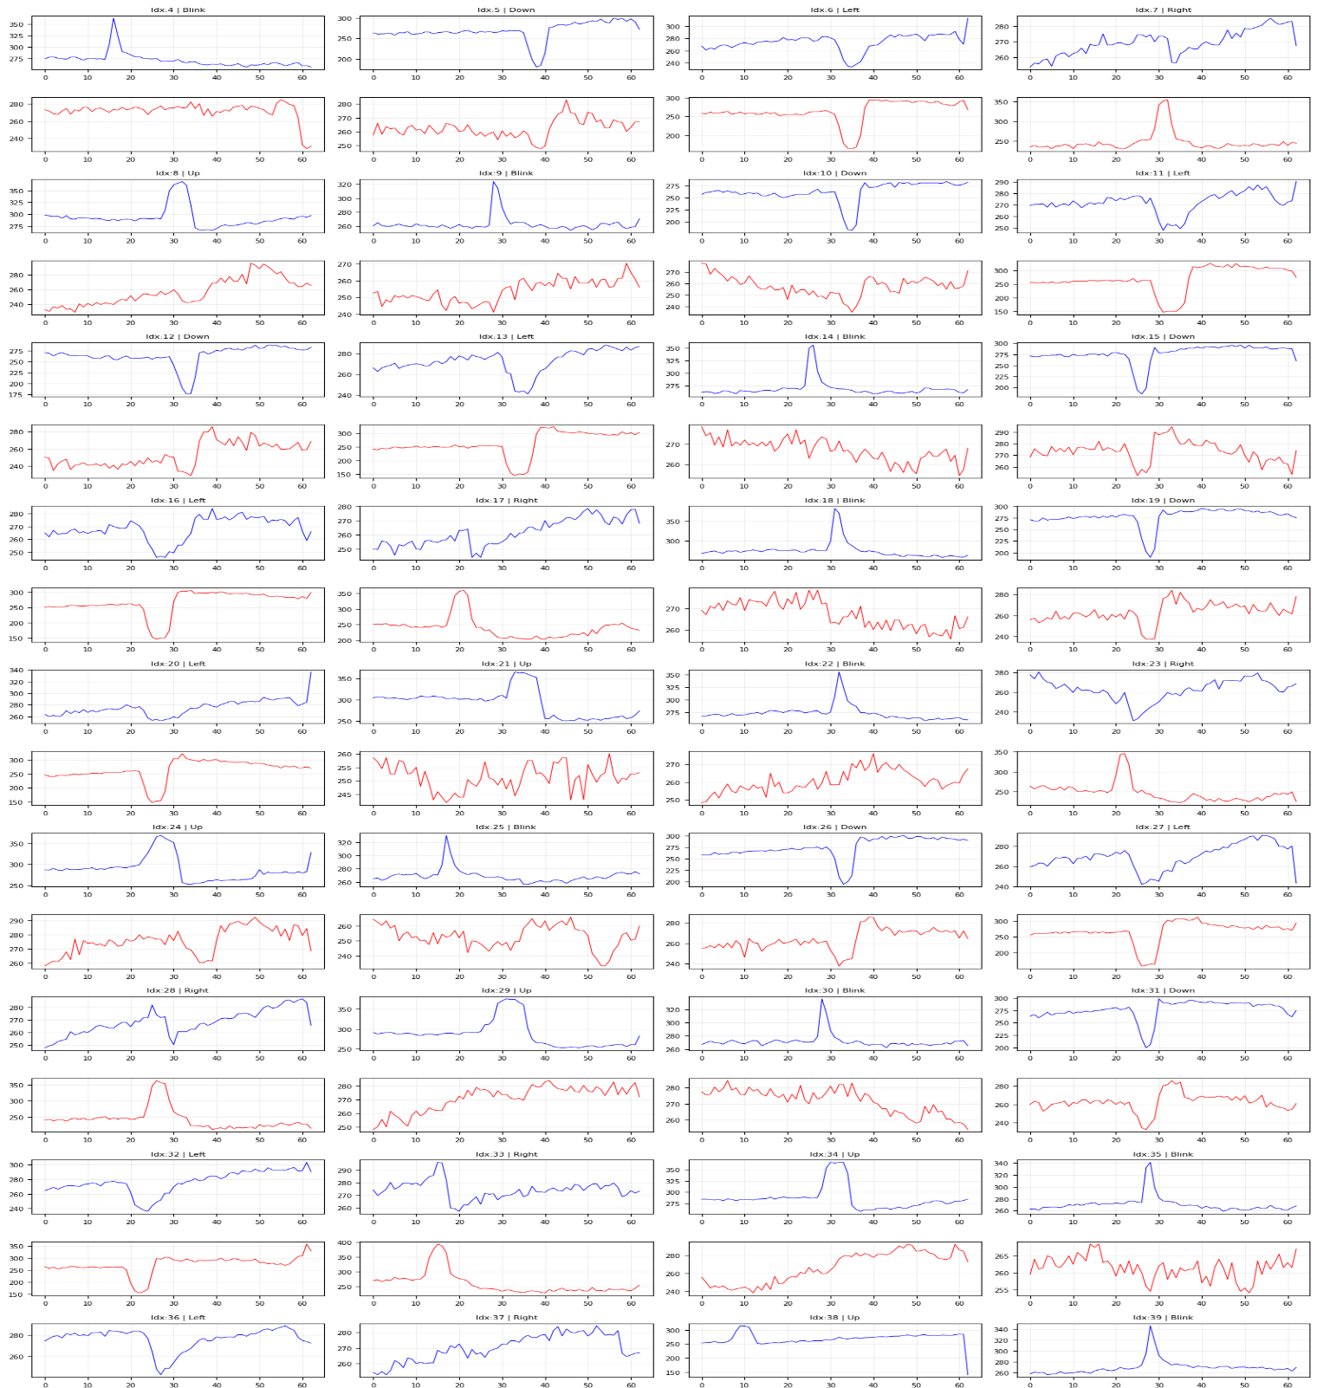
  - Parameter Tuning: It introduces additional design choices, such as selecting the appropriate "Mother Wavelet" (e.g., Daubechies 4) and the optimal depth of decomposition.
Figure3.3 wavelet coefficients

3.4 Power Spectral Density (PSD) Features:-
The PSD, computed using the Periodogram method, estimates the power distribution of the EOG signal across different frequency components. By filtering the output to only include frequencies up to 40 Hz, this method isolates the specific spectral bands most relevant to human eye movements and blinks.
- Advantages:
- Targeted Noise Reduction: By explicitly truncating the feature vector to exclude frequencies above 40 Hz, the model automatically discards high-frequency artifacts (like powerline interference and EMG noise) without requiring complex time-domain filters.
- Energy Distribution Focus: PSD provides a clear representation of signal power, making it highly effective for the SVM to distinguish between resting states (low power) and active eye movements (high power) based on their distinct energy profiles.
- Disadvantages:
  - Loss of Temporal Resolution: The Periodogram method transforms the signal entirely into the frequency domain, losing critical timing information about exactly when the eye movement or blink occurred within the analysis window.
  - Spectral Leakage: Periodograms can suffer from spectral leakage and high variance, which might introduce inconsistencies into the feature vector, especially if the analyzed signal window is too short.

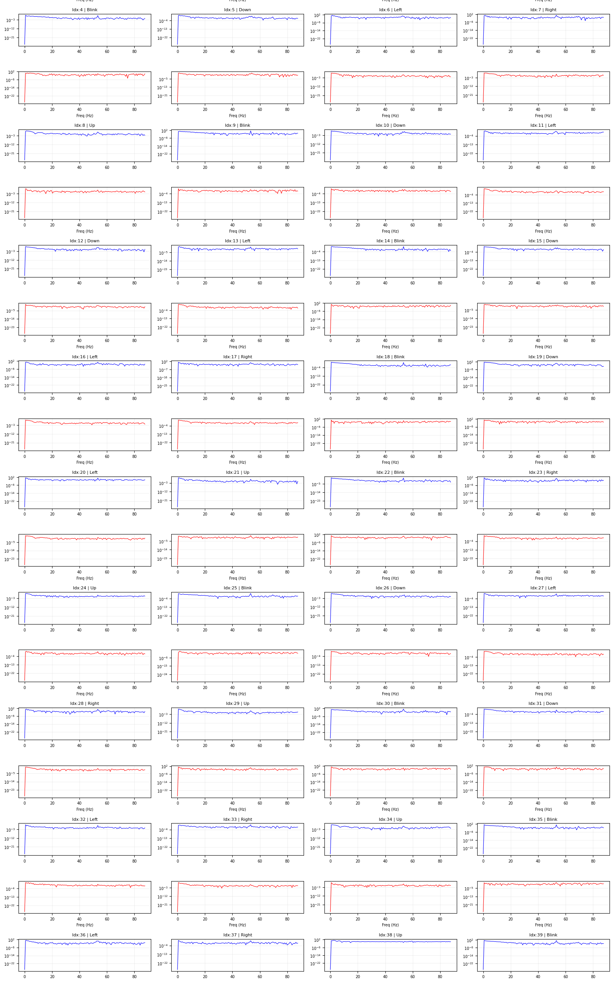
Figure 3.4 PSD Components

3.5 Morphological and Statistical (Mix) Features:-
This hybrid approach extracts direct physical characteristics (morphology) and statistical properties directly from the raw time-domain EOG signal. The extracted features include the maximum peak amplitude, the area under the curve (calculated via Simpson's rule), as well as the signal's mean, variance, and standard deviation.
- Advantages:
- Direct Physical Correlation: Morphological features like the maximum peak and area under the curve (AUC) correlate directly with the physical intensity, amplitude, and duration of an eye movement, providing highly intuitive features for classification.
- Low Computational Cost: Calculating basic statistical measures and finding peaks are computationally inexpensive operations, making this extraction method exceptionally fast and well-suited for real-time human-computer interfaces.
- Disadvantages:
  - Susceptibility to Artifacts: Because these specific features are derived directly from the raw, unfiltered signal, they are highly sensitive to baseline drift, DC offsets, and sudden high-frequency spikes, which can skew the statistical mean or create false peaks.
  - Feature Redundancy: Including both variance and standard deviation in the exact same feature vector introduces mathematical redundancy. Since they represent the same underlying data spread, this adds unnecessary dimensionality without providing new discriminatory information for the SVM.

Chapter 4 : Machine Learning and Classification

4.Machine Learning and Classification:-
This section outlines the machine learning pipeline designed to classify EOG feature vectors into specific calculator commands using a Support Vector Machine (SVM).

4.1 Data Preparation & Processing Pipeline
The horizontal and vertical EOG signals were first concatenated to form a unified feature space. The data was then partitioned into training (80%) and testing (20%) sets using stratified sampling to maintain consistent class proportions. To prevent data leakage and ensure uniform scaling, a pipeline (make pipeline) was implemented to apply Z-score normalization (StandardScaler) immediately before classification.

4.2 SVM Configuration (One-vs-One)
Operating the calculator requires distinguishing between multiple commands (digits and operations). Therefore, the SVM was configured with a One-vs-One (OvO) multiclass strategy. A Radial Basis Function (RBF) kernel was utilized to effectively capture non-linear relationships in the data, with hyperparameters set to balanced values (C=1, gamma='scale').

4.3 Evaluation & Feature Selection
To identify the optimal feature extraction method, the constructed pipeline was executed independently across all five evaluated feature sets: Raw Data, Autoregression (AR), Wavelets, Power Spectral Density (PSD), and Mixed Features. The reliability of each method was measured using both direct Test Accuracy (on the 20% hold-out set) and 5-Fold Cross-Validation (on the training set). The system dynamically compares these scores to select the best-performing feature representation for the final interface.

Chapter 5 : Results and Conclusion

1.Results:-
Validation Accuracy | Test Accuracy | Feature
91.25% | 85% | Raw Data
92.50% | 90% | Wavelet
92.50% | 90% | PSD
71.25% | 80% | AR
93.75% | 95% | Mix

2.Conclusion:-
The evaluation demonstrates that feature selection significantly impacts the SVM classifier's performance. The Mix features (Morphological and Statistical) and Wavelet Transform are the most effective, both achieving a peak Test Accuracy of 95%.
However, the Mix method is the optimal choice due to its superior stability (93.75% Validation Accuracy). It successfully captures the direct physical intensity of eye movements. Wavelets also perform exceptionally well because they handle the non-stationary nature of EOG signals.
Conversely, Autoregression (AR) yielded the poorest results (dropping to 66.25% Validation Accuracy). AR mathematically assumes signal stationarity, an assumption heavily violated by the abrupt nature of eye movements, which caused the model to severely overfit.

